**ALGORITHM AND DATA STRUCTURE PRACTICUM**

**MODULE 6**

**ADVANCED ORDERING**



**CREATED BY :**

**KURNIAWAN BAGASKARA**

**L200214253**

**INFORMATICS STUDY PROGRAM**

**FACULTY OF COMMUNICATION AND INFORMATION SCIENCE**

**MUHAMMADIYAH SURAKARTA UNIVERSITY**

**TASK.**

1.from latihan import *

from mahasiswa import *

def convert(arr, obj):

hasil=[]

for x in range (len(arr)):

for i in range (len(arr)):

if arr[x] == obj[i].nim:

hasil.append(obj[i])

return hasil

def urutkanQuick():

A = []

for x in Daftar:

A.append(x.nim)

print("Quick Sort")

quickSort(A)

for x in convert(A, Daftar):

print (x.nim)

def urutkanMerge():

A = []

for x in Daftar:

A.append(x.nim)

print("\nMerge Sort")

mergeSort(A)

for x in convert(A, Daftar):

print (x.nim)

urutkanQuick()

urutkanMerge()

print("Kurniawan Bagaskara")

print("L200214253")

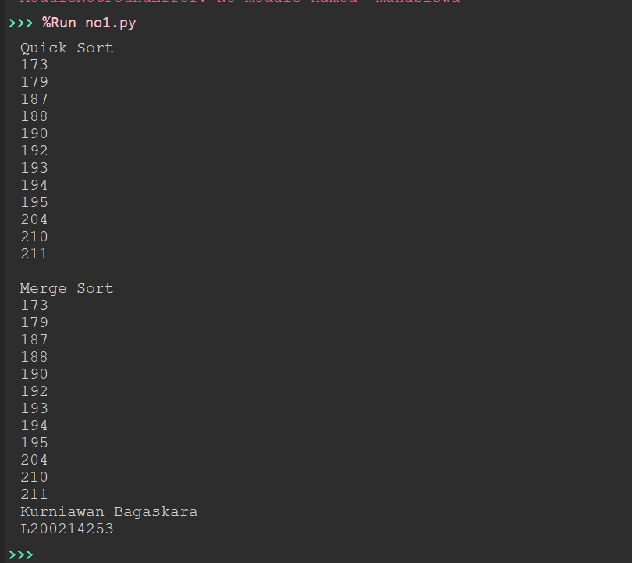

2.

from time import time as detak

from random import shuffle as kocok

import time

def swap(A, p, q):

tmp = A[p]

A[p] = A[q]

A[q] = tmp

def cariPosisiYangTerkecil(A, dariSini, sampaiSini):

posisiYangTerkecil = dariSini

for i in range(dariSini+1, sampaiSini):

if A[i] < A[posisiYangTerkecil]:

posisiYangTerkecil = i

return posisiYangTerkecil

def bubbleSort(S):

n = len(S)

for i in range (n-1):

for j in range (n-i-1):

if S[j] > S[j+1]:

swap(S,j,j+1)

return S

def selectionSort(S):

n = len(S)

for i in range(n-1):

indexKecil = cariPosisiYangTerkecil(S, i, n)

if indexKecil != i:

swap(S, i, indexKecil)

return S

def insertionSort(S):

n = len(S)

for i in range(1, n):

nilai = S[i]

pos = i

while pos > 0 and nilai < S[pos -1]:

S[pos] = S[pos-1]

pos = pos - 1

S[pos] = nilai

return S

def mergeSort(A):

#print("Membelah ",A)

if len(A) > 1:

mid = len(A) // 2

separuhkiri = A[:mid]

separuhkanan = A[mid:]

mergeSort(separuhkiri)

mergeSort(separuhkanan)

i = 0;j=0;k=0

while i < len(separuhkiri) and j < len(separuhkanan):

if separuhkiri[i] < separuhkanan[j]:

A[k] = separuhkiri[i]

i = i + 1

else:

A[k] = separuhkanan[j]

j = j + 1

k=k+1

while i < len(separuhkiri):

A[k] = separuhkiri[i]

i = i + 1

k=k+1

while j < len(separuhkanan):

A[k] = separuhkanan[j]

j = j + 1

k=k+1

#print("Menggabungkan",A)

def partisi(A, awal, akhir):

nilaipivot = A[awal]

penandakiri = awal + 1

penandakanan = akhir

selesai = False

while not selesai:

while penandakiri <= penandakanan and A[penandakiri] <= nilaipivot:

penandakiri = penandakiri + 1

while penandakanan >= penandakiri and A[penandakanan] >= nilaipivot:

penandakanan = penandakanan - 1

if penandakanan < penandakiri:

selesai = True

else:

temp = A[penandakiri]

A[penandakiri] = A[penandakanan]

A[penandakanan] = temp

temp = A[awal]

A[awal] = A[penandakanan]

A[penandakanan] = temp

return penandakanan

def quickSortBantu(A, awal, akhir):

if awal < akhir:

titikBelah = partisi(A, awal, akhir)

quickSortBantu(A, awal, titikBelah-1)

quickSortBantu(A, titikBelah+1, akhir)

def quickSort(A):

quickSortBantu (A, 0, len(A)-1)

daftar = [10, 51, 2, 18, 4, 31, 13, 5, 23, 64, 29]

k = [[i] for i in range(1, 6001)]

kocok(k)

u_bub = k[:]

u_sel = k[:]

u_ins = k[:]

u_mrg = k[:]

u_qck = k[:]

aw=detak();bubbleSort(u_bub);ak=detak();print("bubble: %g detik" %(ak-aw));

aw=detak();selectionSort(u_sel);ak=detak();print("selection: %g detik" %(ak-aw));

aw=detak();insertionSort(u_ins);ak=detak();print("insertion: %g detik" %(ak-aw));

aw=detak();mergeSort(u_mrg);ak=detak();print("merge: %g detik" %(ak-aw));

aw=detak();quickSort(u_qck);ak=detak();print("quick: %g detik" %(ak-aw));

print("Kurniawan Bagaskara")

print("L200214253")

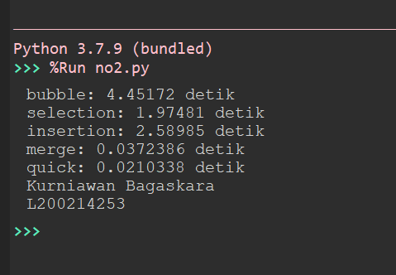

3.

from time import time as detak

from random import shuffle as kocok

import time

def swap(A, p, q):

tmp = A[p]

A[p] = A[q]

A[q] = tmp

def cariPosisiYangTerkecil(A, dariSini, sampaiSini):

posisiYangTerkecil = dariSini

for i in range(dariSini+1, sampaiSini):

if A[i] < A[posisiYangTerkecil]:

posisiYangTerkecil = i

return posisiYangTerkecil

def bubbleSort(S):

n = len(S)

for i in range (n-1):

for j in range (n-i-1):

if S[j] > S[j+1]:

swap(S,j,j+1)

return S

def selectionSort(S):

n = len(S)

for i in range(n-1):

indexKecil = cariPosisiYangTerkecil(S, i, n)

if indexKecil != i:

swap(S, i, indexKecil)

return S

def insertionSort(S):

n = len(S)

for i in range(1, n):

nilai = S[i]

pos = i

while pos > 0 and nilai < S[pos -1]:

S[pos] = S[pos-1]

pos = pos - 1

S[pos] = nilai

return S

def mergeSort(A):

#print("Membelah ",A)

if len(A) > 1:

mid = len(A) // 2

separuhkiri = A[:mid]

separuhkanan = A[mid:]

mergeSort(separuhkiri)

mergeSort(separuhkanan)

i = 0;j=0;k=0

while i < len(separuhkiri) and j < len(separuhkanan):

if separuhkiri[i] < separuhkanan[j]:

A[k] = separuhkiri[i]

i = i + 1

else:

A[k] = separuhkanan[j]

j = j + 1

k=k+1

while i < len(separuhkiri):

A[k] = separuhkiri[i]

i = i + 1

k=k+1

while j < len(separuhkanan):

A[k] = separuhkanan[j]

j = j + 1

k=k+1

#print("Menggabungkan",A)

def partisi(A, awal, akhir):

nilaipivot = A[awal]

penandakiri = awal + 1

penandakanan = akhir

selesai = False

while not selesai:

while penandakiri <= penandakanan and A[penandakiri] <= nilaipivot:

penandakiri = penandakiri + 1

while penandakanan >= penandakiri and A[penandakanan] >= nilaipivot:

penandakanan = penandakanan - 1

if penandakanan < penandakiri:

selesai = True

else:

temp = A[penandakiri]

A[penandakiri] = A[penandakanan]

A[penandakanan] = temp

temp = A[awal]

A[awal] = A[penandakanan]

A[penandakanan] = temp

return penandakanan

def quickSortBantu(A, awal, akhir):

if awal < akhir:

titikBelah = partisi(A, awal, akhir)

quickSortBantu(A, awal, titikBelah-1)

quickSortBantu(A, titikBelah+1, akhir)

def quickSort(A):

quickSortBantu (A, 0, len(A)-1)

k = list(range(6000))

kocok(k)

u_bub = k[:]

u_sel = k[:]

u_ins = k[:]

u_mrg = k[:]

u_qck = k[:]

aw=detak();bubbleSort(u_bub);ak=detak();print('bubble: %g detik' %(ak-aw) );

aw=detak();selectionSort(u_sel);ak=detak();print('selection: %g detik' %(ak-aw) );

aw=detak();insertionSort(u_ins);ak=detak();print('insertion: %g detik' %(ak-aw) );

aw=detak();mergeSort(u_mrg);ak=detak();print('merge: %g detik' %(ak-aw) );

aw=detak();quickSort(u_qck);ak=detak();print('quick: %g detik' %(ak-aw) );

print("Kurniawan Bagaskara")

print("L200214253")

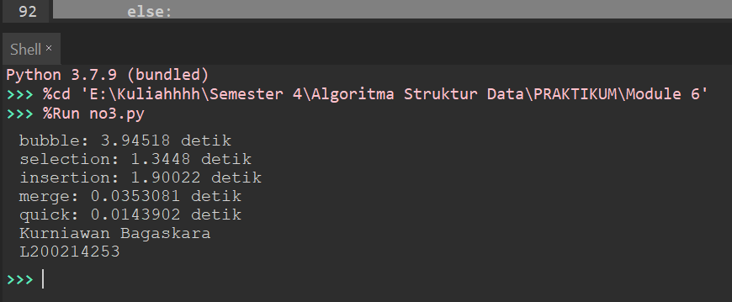

4.

from latihan62 import *

from latihan63 import *

L = [80, 7, 24, 16, 43, 91, 35, 2, 19, 72]

mergeSort(L)

print(L)

quickSort(L)

print(L)

print("Kurniawan Bagaskara")

print("L200214253")

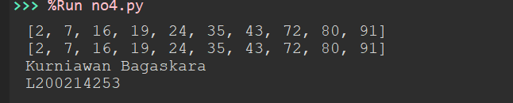

5.

from mahasiswa import *

def cetak(A):

for i in A:

print (i)

def mergeSort2(A, awal, akhir):

mid = (awal+akhir)//2

if awal < akhir:

mergeSort2(A, awal, mid)

mergeSort2(A, mid+1, akhir)

a, f, l = 0, awal, mid+1

tmp = [None] * (akhir - awal + 1)

while f <= mid and l <= akhir:

if A[f].ambilUangSaku() < A[l].ambilUangSaku():

tmp[a] = A[f]

f += 1

else:

tmp[a] = A[l]

l += 1

a += 1

if f <= mid:

tmp[a:] = A[f:mid+1]

if l <= akhir:

tmp[a:] = A[l:akhir+1]

a = 0

while awal <= akhir:

A[awal] = tmp[a]

awal += 1

a += 1

def mergeSort(A):

mergeSort2(A, 0, len(A)-1)

print("Sebelum diurutkan")

cetak(Daftar)

mergeSort(Daftar)

print("\nSetelah diurutkan")

cetak(Daftar)

print("Kurniawan Bagaskara")

print("L200214253")

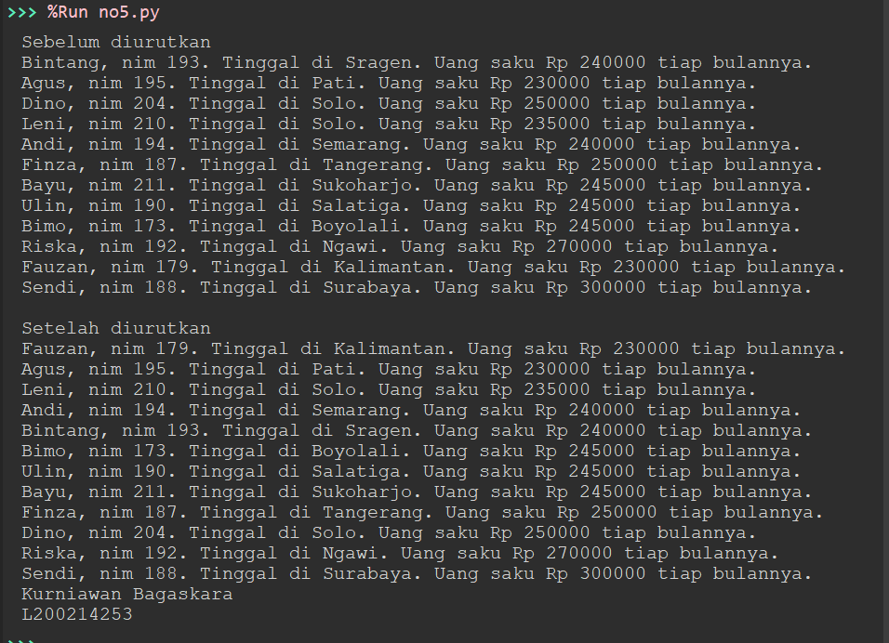

6.

from mahasiswa import *

def cetak(A):

for i in A:

print(i)

def quickSort(arr):

kurang = []

pivotList = []

lebih = []

if len(arr) <= 1:

return arr

else:

pivot = arr[0]

for i in arr:

if i.ambilUangSaku() < pivot.ambilUangSaku():

kurang.append(i)

elif i.ambilUangSaku() > pivot.ambilUangSaku():

lebih.append(i)

else:

pivotList.append(i)

kurang = quickSort(kurang)

lebih = quickSort(lebih)

return kurang + pivotList + lebih

print("Sebelum diurutkan")

cetak(Daftar)

quickSort(Daftar)

print("\nSetelah diurutkan")

cetak(Daftar)

print("Kurniawan Bagaskara")

print("L200214253")

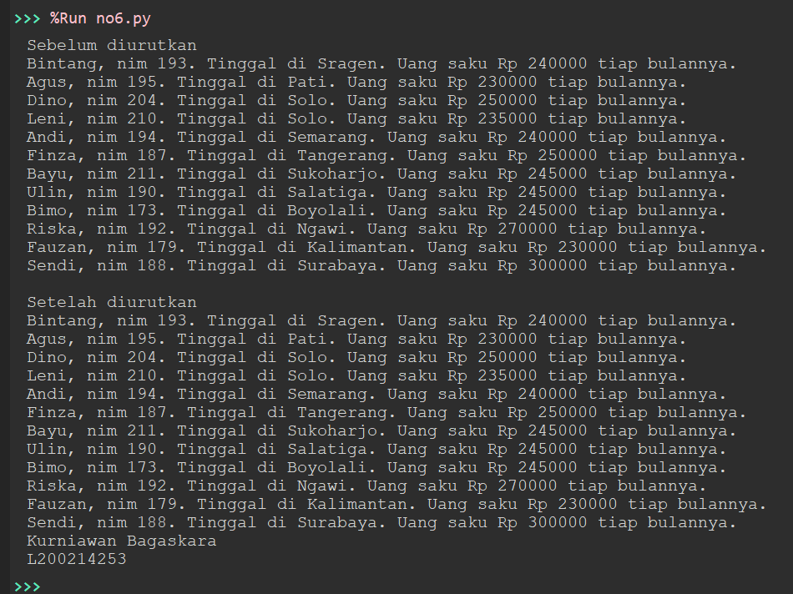

7.

from time import time as detak

from random import shuffle as kocok

import time

def mergeSort(A):

#print("Membelah ",A)

if len(A) > 1:

mid = len(A) // 2

separuhkiri = A[:mid]

separuhkanan = A[mid:]

mergeSort(separuhkiri)

mergeSort(separuhkanan)

i = 0;j=0;k=0

while i < len(separuhkiri) and j < len(separuhkanan):

if separuhkiri[i] < separuhkanan[j]:

A[k] = separuhkiri[i]

i = i + 1

else:

A[k] = separuhkanan[j]

j = j + 1

k=k+1

while i < len(separuhkiri):

A[k] = separuhkiri[i]

i = i + 1

k=k+1

while j < len(separuhkanan):

A[k] = separuhkanan[j]

j = j + 1

k=k+1

#print("Menggabungkan",A)

def partisi(A, awal, akhir):

nilaipivot = A[awal]

penandakiri = awal + 1

penandakanan = akhir

selesai = False

while not selesai:

while penandakiri <= penandakanan and A[penandakiri] <= nilaipivot:

penandakiri = penandakiri + 1

while penandakanan >= penandakiri and A[penandakanan] >= nilaipivot:

penandakanan = penandakanan - 1

if penandakanan < penandakiri:

selesai = True

else:

temp = A[penandakiri]

A[penandakiri] = A[penandakanan]

A[penandakanan] = temp

temp = A[awal]

A[awal] = A[penandakanan]

A[penandakanan] = temp

return penandakanan

def quickSortBantu(A, awal, akhir):

if awal < akhir:

titikBelah = partisi(A, awal, akhir)

quickSortBantu(A, awal, titikBelah-1)

quickSortBantu(A, titikBelah+1, akhir)

def quickSort(A):

quickSortBantu (A, 0, len(A)-1)

def mergeSort2(A, awal, akhir):

mid = (awal+akhir)//2

if awal < akhir:

mergeSort2(A, awal, mid)

mergeSort2(A, mid+1, akhir)

a, f, l = 0, awal, mid+1

tmp = [None] * (akhir - awal + 1)

while f <= mid and l <= akhir:

if A[f] < A[l]:

tmp[a] = A[f]

f += 1

else:

tmp[a] = A[l]

l += 1

a += 1

if f <= mid:

tmp[a:] = A[f:mid+1]

if l <= akhir:

tmp[a:] = A[l:akhir+1]

a = 0

while awal <= akhir:

A[awal] = tmp[a]

awal += 1

a += 1

def mergeSortNew(A):

mergeSort2(A, 0, len(A)-1)

def quickSortNew(arr):

kurang = []

pivotList = []

lebih = []

if len(arr) <= 1:

return arr

else:

pivot = arr[0]

for i in arr:

if i < pivot:

kurang.append(i)

elif i > pivot:

lebih.append(i)

else:

pivotList.append(i)

kurang = quickSortNew(kurang)

lebih = quickSortNew(lebih)

return kurang + pivotList + lebih

daftar = [10, 51, 2, 18, 4, 31, 13, 5, 23, 64, 29]

mergeSort(daftar)

print (daftar)

quickSort(daftar)

print (daftar)

mergeSortNew(daftar)

print (daftar)

quickSortNew(daftar)

print (daftar)

k = [[i] for i in range(1, 6001)]

kocok(k)

u_mrg = k[:]

u_qck = k[:]

u_mrgNew = k[:]

u_qckNew = k[:]

aw=detak();mergeSort(u_mrg);ak=detak();print("merge: %g detik" %(ak-aw));

aw=detak();quickSort(u_qck);ak=detak();print("quick: %g detik" %(ak-aw));

aw=detak();mergeSortNew(u_mrgNew);ak=detak();print("merge New: %g detik" %(ak-aw));

aw=detak();quickSortNew(u_qckNew);ak=detak();print("quick New: %g detik" %(ak-aw));

print("Kurniawan Bagaskara")

print("L200214253")

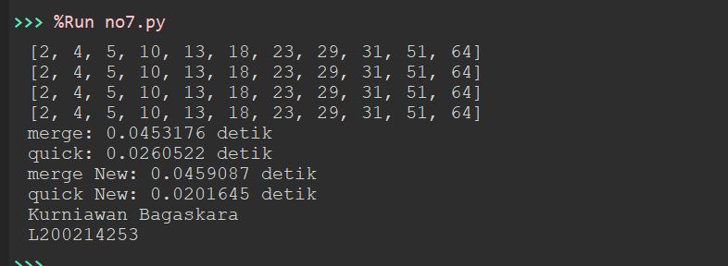

8.

class Node():

def __init__(self, data, tautan=None):

self.data = data

self.tautan = tautan

def cetak(head):

curr = head

while curr is not None:

try:

print (curr.data)

curr = curr.tautan

except:

pass

a = Node(1)

b = Node(3)

c = Node(5)

d = Node(7)

e = Node(2)

f = Node(4)

g = Node(6)

a.tautan = b

b.tautan = c

c.tautan = d

d.tautan = e

e.tautan = f

f.tautan = g

def mergeSortLL(A):

linked = A

try:

daftar = []

curr = A

while curr:

daftar.append(curr.data)

curr = curr.tautan

A = daftar

except:

A = A

if len(A) > 1:

mid = len(A) // 2

separuhkiri = A[:mid]

separuhkanan = A[mid:]

mergeSortLL(separuhkiri)

mergeSortLL(separuhkanan)

i = 0;j=0;k=0

while i < len(separuhkiri) and j < len(separuhkanan):

if separuhkiri[i] < separuhkanan[j]:

A[k] = separuhkiri[i]

i = i + 1

else:

A[k] = separuhkanan[j]

j = j + 1

k=k+1

while i < len(separuhkiri):

A[k] = separuhkiri[i]

i = i + 1

k=k+1

while j < len(separuhkanan):

A[k] = separuhkanan[j]

j = j + 1

k=k+1

for x in A:

try:

linked.data = x

linked = linked.tautan

except:

pass

mergeSortLL(a)

cetak(a)

print("Kurniawan Bagaskara")

print("L200214253")

